

Student Name:………………………………………

SPECIALIST MATHEMATICS

TRIAL EXAMINATION 2

2014

Reading Time: 15 minutes
Writing time: 2 hours

Instructions to students
This exam consists of Section 1 and Section 2.
Section 1 consists of 22 multiple-choice questions and should be answered on the detachable answer sheet on page 29 of this exam. This section of the paper is worth 22 marks.
Section 2 consists of 5 extended-answer questions, all of which should be answered in the spaces provided. Section 2 begins on page 10 of this exam. This section of the paper is worth 58 marks.
There is a total of 80 marks available.
Where more than one mark is allocated to a question, appropriate working must be shown.
Where an exact value is required to a question a decimal approximation will not be accepted.
Unless otherwise stated, diagrams in this exam are not drawn to scale.
The acceleration due to gravity should be taken to have magnitude 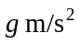where 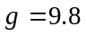
Students may bring one bound reference into the exam.
Students may bring into the exam one approved CAS calculator or CAS software and, if desired, one scientific calculator. Calculator memory does not need to be cleared.
Formula sheets can be found on pages 26-28 of this exam.

This paper has been prepared independently of the Victorian Curriculum and Assessment Authority to provide additional exam preparation for students. Although references have been reproduced with permission of the Victorian Curriculum and Assessment Authority, the publication is in no way connected with or endorsed by the Victorian Curriculum and Assessment Authority.
© THE HEFFERNAN GROUP 2014
This Trial Exam is licensed on a non transferable basis to the purchasing school. It may be copied by the school which has purchased it. This license does not permit distribution or copying of this Trial Exam by any other party.
SECTION 1

Question 1

The following equations each represent a hyperbola.
Which hyperbola has the maximum and minimum points of its two branches located on the
y-axis?

- 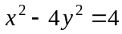
- 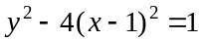
- 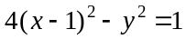
- 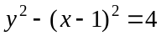
- 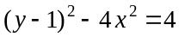

Question 2

The graph of 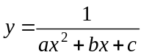 has, as its asymptotes, the x and y axes and the line .
The y-coordinate of the maximum turning point on the graph is 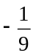.
The values of a, b and c are

- 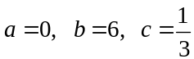
- 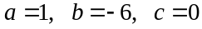
- 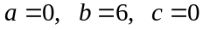
- 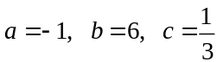
- 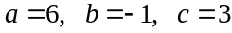

Question 3

The graph of 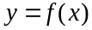 has a period of and f is not defined at 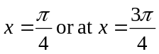.
The rule for f could be

- 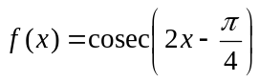
- 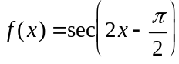
- 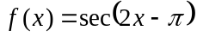
- 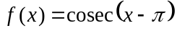
- 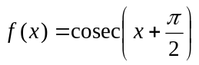

Question 4

The implied range of the function with rule 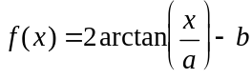 is
- 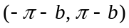
- 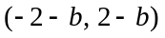
- 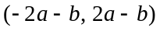
- 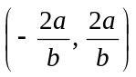
- 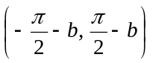

Question 5

The graph of 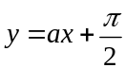 intersects with the graph of 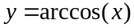 exactly three times if
- 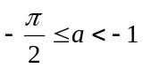
- 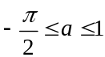

Question 6

Let 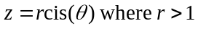.
The expression 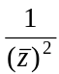 is equal to

- 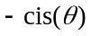
- 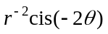
- 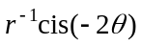
- 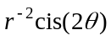
- 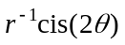

Question 7

In the complex plane, a straight line passes through the origin. This line could be defined by the set of points 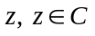, such that

- 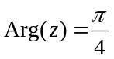
- 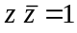
- 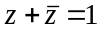
- 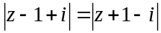
- 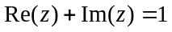
Question 8

The solutions to the equation 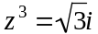 have principal arguments of

- 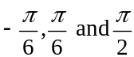
- 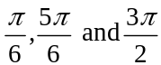
- 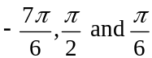
- 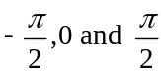
- 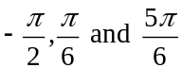

Question 9

The roots of the equation 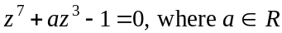, are displayed on an Argand diagram.
That diagram could be

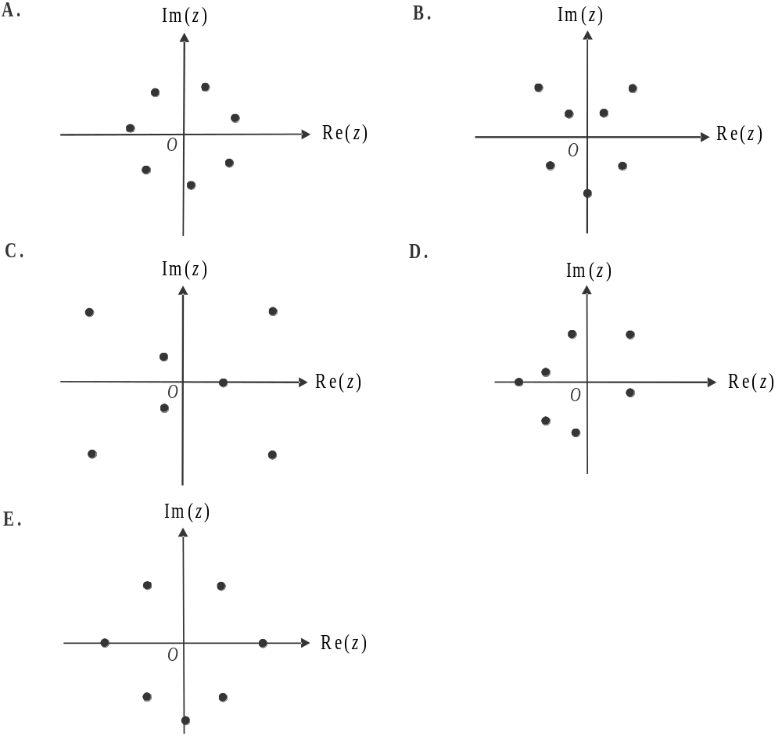

Question 10

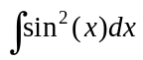 is equal to

- 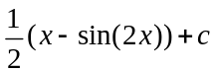
- 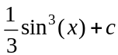
- 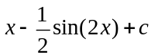
- 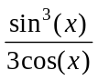
- 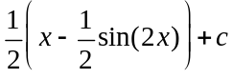

Question 11

Using a suitable substitution, 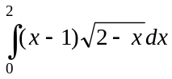 is equivalent to

- 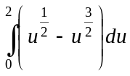
- 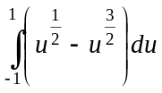
- 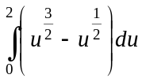
- 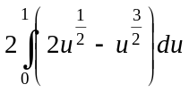
- 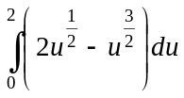

Question 12
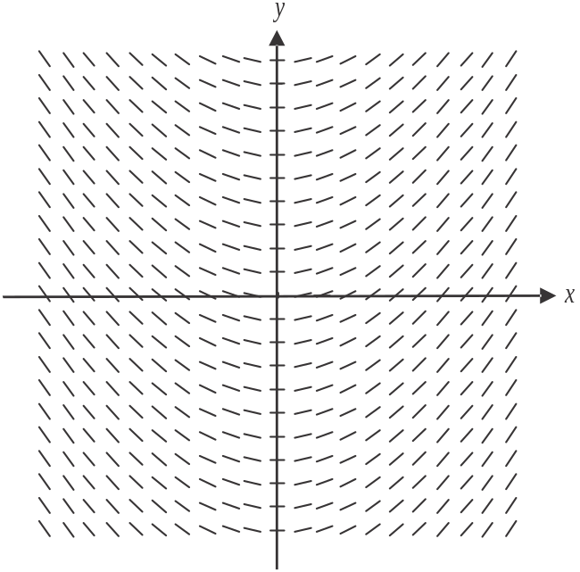

The direction field shown above is best represented by the differential equation

- 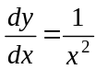
- 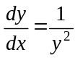
- 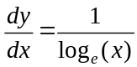
- 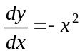
- 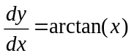

Question 13

If 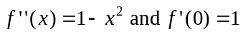, then the graph of

- has three stationary points
- has two maximum turning points
- must pass through the origin
- has two points of inflection
- has a stationary point of inflection.
Question 14

Let 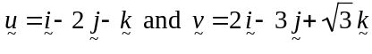.
The scalar resolute of in the direction of is

- 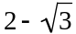
- 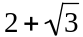
- 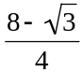
- 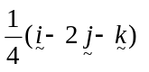
- 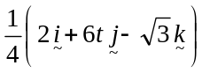

Question 15

ABCD is a parallelogram. The position vectors of A, B, C and D are given respectively by
.
The values of m and n are

Question 16

The diagram below shows a particle which is in equilibrium whilst being acted on by three forces of magnitude 11, 6 and F newtons.

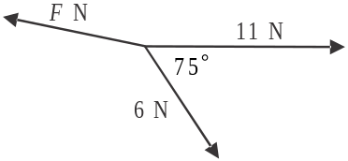

The magnitude of force F, in newtons, is given by the expression

- 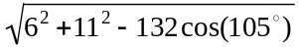
- 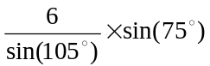
- 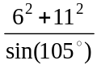
- 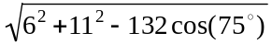
- 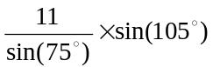
Question 17

The position vectors of particles A and B at time t, are given respectively by
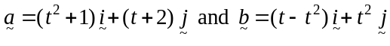 where 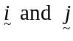 are unit vectors in the east and north directions respectively.
Particle A is due east of particle B when t equals

- 0
- 1
- 2
- 3
- 4

Question 18

The normal to a curve at any point on it 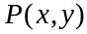 cuts the x-axis at .
satisfies the differential equation given by

- 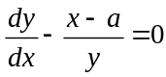
- 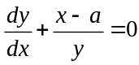
- 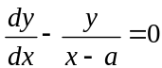
- 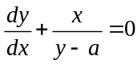
- 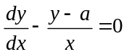

Question 19

A particle moving in a straight line has an acceleration a where 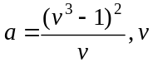 is its velocity and x is its displacement from an origin O.
If 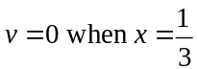, then the velocity v in terms of x is

- 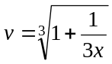
- 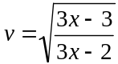
- 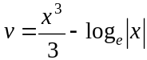
- 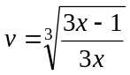
- 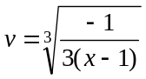
Question 20

A crane lifts an enclosed crate containing a load of 240kg. The acceleration of the crate is 5m/s² vertically upwards.
The reaction of the base of the crate on the load, expressed in newtons, is

- 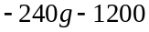
- 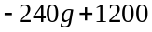
- 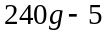
- 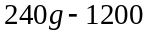
- 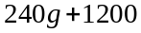

Question 21

A particle of mass 5kg is moving in a straight line with a velocity of 6m/s when it is acted on by a constant force of magnitude F newtons, acting in the same direction.
After travelling a further 50 metres, the velocity of the particle is 12m/s.
The value of F is

- 4.6
- 5.4
- 7.2
- 9.0
- 23.2

Question 22

A particle moves in a straight line with respect to a fixed point. The velocity-time graph of the particle is shown below.
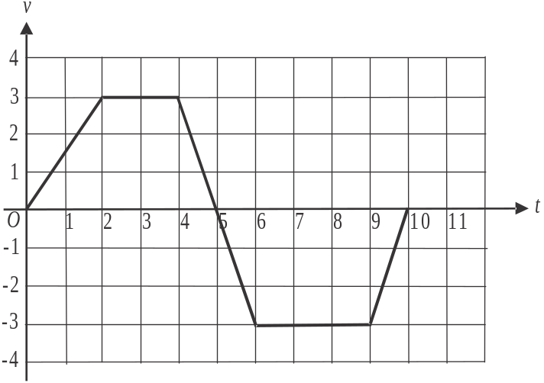

Initially the particle is 2 units from the fixed point.
Its possible displacement from the fixed point 10 seconds later could be

- – 3.5
- – 1.5
C. – 1.0
D. 1.0
E. 1.5
SECTION 2

Question 1 (11 marks)

Consider the function f with rule 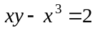.

- Show that 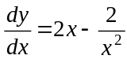. 1 mark

- Sketch the graph of on the set of axes below. Indicate clearly any axes intercepts and stationary points as well as the asymptotes of the graph. 3 marks

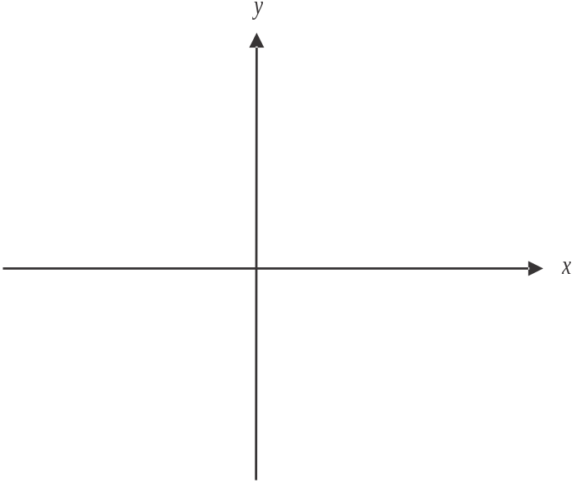

- Find 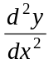. 1 mark

Let the gradient of the graph of f be m.

- If there are three points on the graph of f where the gradient is m, find the possible values of m. 3 marks

The region enclosed by the graph of , the x-axis and the lines , is rotated about the x-axis to form a solid of revolution.

- i. Write down a definite integral that gives the volume of this solid of revolution. 2 marks

- Find the volume of this solid of revolution. 1 mark

Question 2 (12 marks)

Let 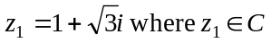.

- Find 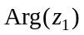. 1 mark

- is a root of the equation 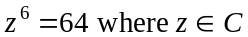.

- Show that is also a root. 1 mark

- Find all the other roots of the equation. 1 mark

The line L, which lies in the complex plane, has the equation 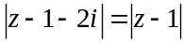.

- Show that the Cartesian equation of L is 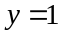. 2 marks

- Find, in Cartesian form, the point of intersection between L and the line 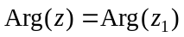. 2 marks

On the Argand diagram below, 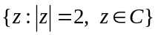 is shown.

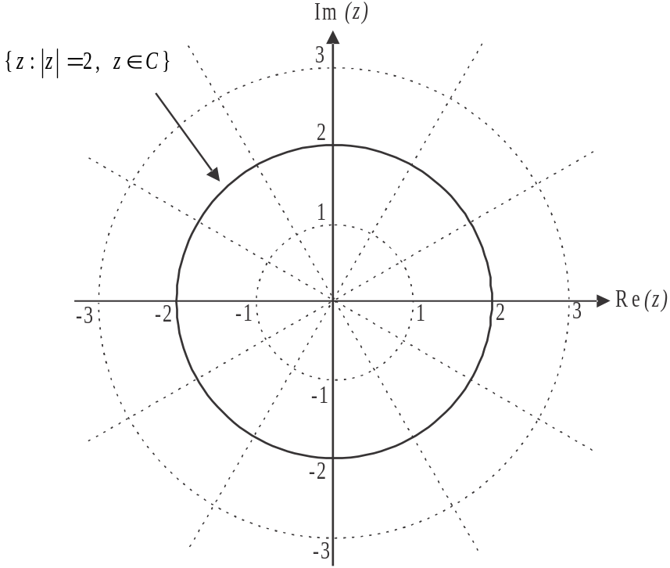

e. On the diagram above, sketch 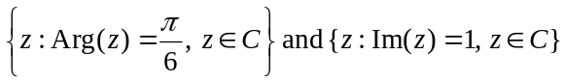. 2 marks

- On the Argand diagram in part e., shade the region defined by . 1 mark

- Find the area of the region shaded in part f. 2 marks

Question 3 (12 marks)

The position vector of point A is 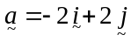, for point B it is 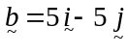, for point C it is 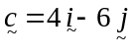 and for point D it is 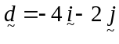 relative to the origin O.

- Use a vector method to show that 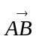 passes through the origin. 2 marks

- Show that 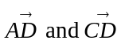 are perpendicular. 2 marks

- Resolve 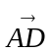 into two vector components, one parallel to 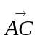 and one perpendicular to . 3 marks

- Find the cosine of , the angle between 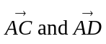, using a vector method. 2 marks

Point P has position vector 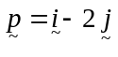.
- Find the cosine of . Hence, using an appropriate trigonometric formula, prove that 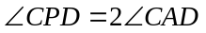. 3 marks

Question 4 (10 marks)

Consider the function f with rule 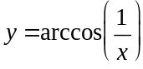.

- Find the maximal domain of f. 1 mark

- Sketch the graph of on the axes below. Indicate clearly any endpoints and asymptotes. 2 marks

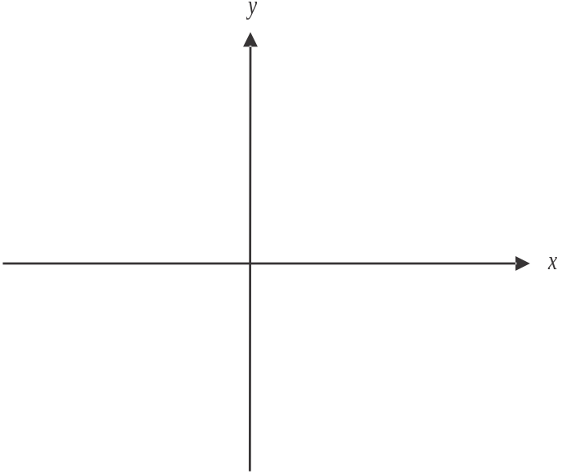

- Show that 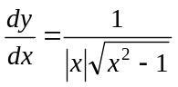. 1 mark

- Hence verify that is a solution to the differential equation 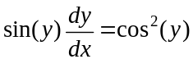 2 marks

- Solve the differential equation . 2 marks

- For the differential equation given in part d., given that 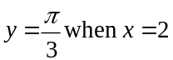 and using Euler’s method with a step size of , find an estimate of the value of y when . Express your answer correct to one decimal place. 2 marks

Question 5 (13 marks)

A snowboarder moves down a long, straight ski slope which has a constant gradient and can be regarded as a plane. He traverses the slope from side to side as viewed from a peak nearby and shown in the diagram below.

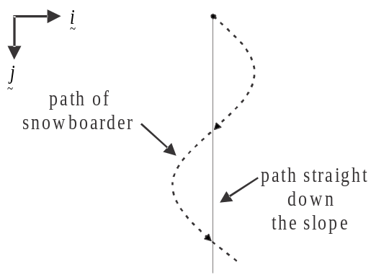

The position vector of the snowboarder relative to a chairlift station nearby is given by

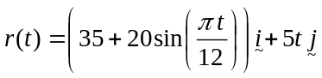

where corresponds to the time, in seconds, that the snowboarder started his run.

The component of the position vector is a unit vector in the direction straight down the slope.
The component of the position vector is a unit vector perpendicular to the component and directed towards the left of the slope as you look down it.
Both components are measured in metres.

- Find the speed of the snowboarder 12 seconds after he starts his run. Express your answer in metres/second correct to 2 decimal places. 2 marks

- Find the time(s) when the magnitude of the acceleration of the snowboarder is a maximum. 3 marks

Later in the day, the snowboarder learns how to make jumps. He begins by practicing on a straight launching pad which is inclined at an angle of 30° to the horizontal snow on which it rests. The snowboarder is to be towed in a straight line along the snow and up the launching pad.
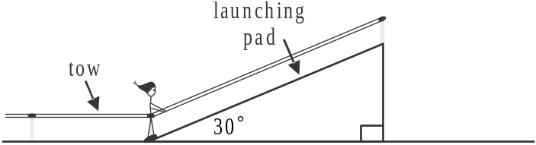

On his first attempt, the snowboarder releases the tow just as he reaches the launching pad. At this point his speed is 7.2m/s. He travels a further 5 metres up the launching pad, decelerating uniformly before momentarily coming to rest.

- Show that the coefficient of friction between the snowboarder’s board and the surface of the launching pad is 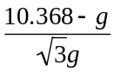. 3 marks

d. Find the acceleration of the snowboarder back down the launching pad after he
momentarily comes to rest. 2 marks

On a later attempt, the snowboarder travels up the entire length of the launching pad at a speed of 10 m/s. At the top of the launching pad, he releases the tow and is airborne until he lands on the snow below. Whilst airborne, the snowboarder is subject only to gravitational force with air resistance being negligible. He lands 13.78 metres horizontally from where he became airborne.

- Find the length of the launching pad. Express your answer in metres correct to one decimal place. 3 marks

Specialist Mathematics Formulas

Mensuration
area of a trapezium: 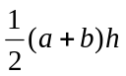
curved surface area of a cylinder: 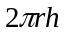
volume of a cylinder: 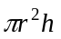
volume of a cone: 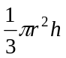
volume of a pyramid: 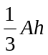
volume of a sphere: 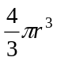
area of a triangle: 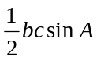
sine rule: 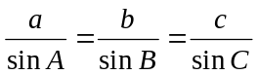
cosine rule: 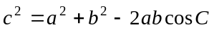

Coordinate geometry
ellipse: 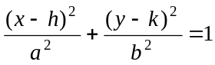 hyperbola: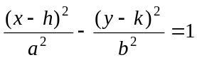

Circular (trigonometric) functions
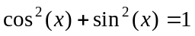
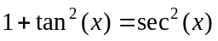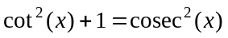
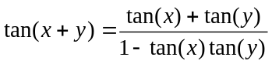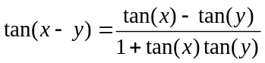
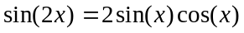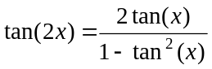
function | 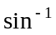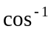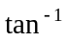
domain  range | 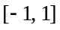  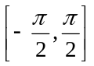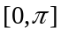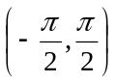

Algebra (Complex numbers)
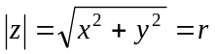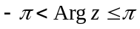
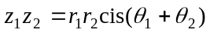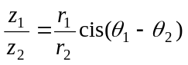
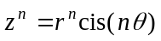 (de Moivre’s theorem)

Mathematics Formula Sheets reproduced by permission; © VCAA 2013. The VCAA does not endorse or make any warranties regarding this study resource. Current and past VCAA VCE® exams and related content can be accessed directly at www.vcaa.vic.edu.au
Calculus

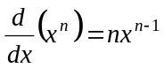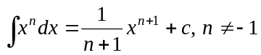
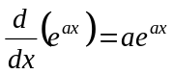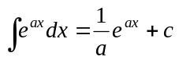
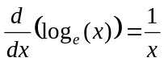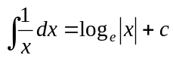
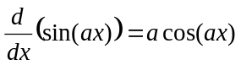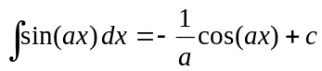
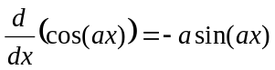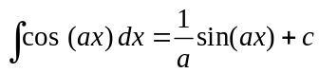
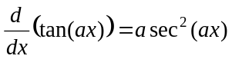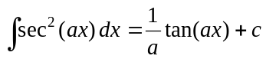
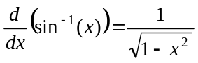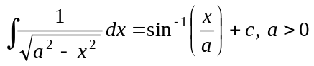
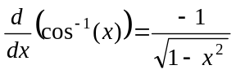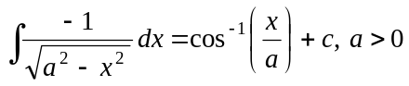
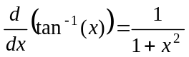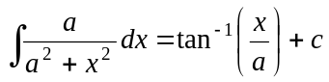

product rule: 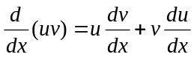
quotient rule: 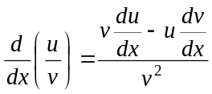
chain rule: 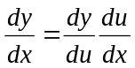
Euler’s method: 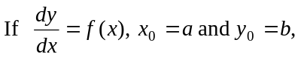
acceleration: 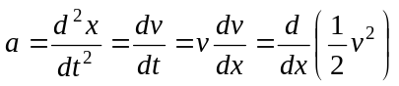
constant (uniform) acceleration: 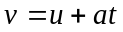 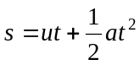 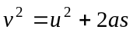 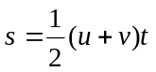

Vectors in two and three dimensions

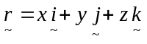
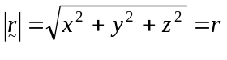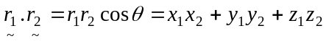
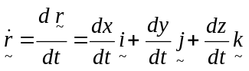

Mechanics

momentum: 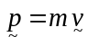
equation of motion: 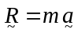
friction: 